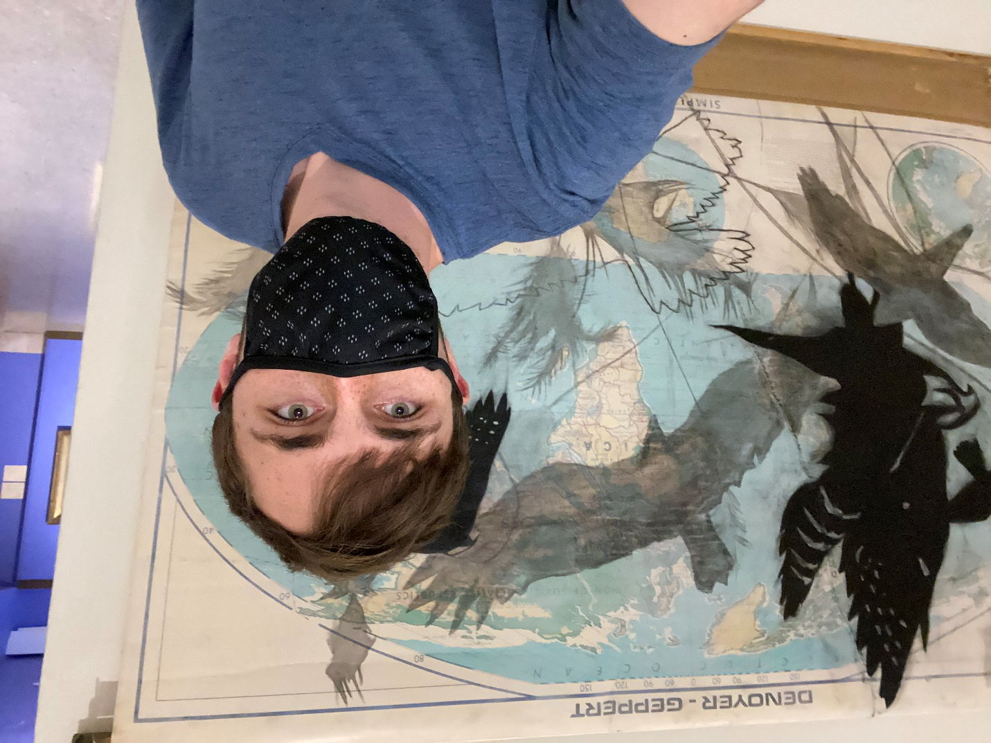

I went to the South Texas Art Museum; it was super cool to see all the art in one style and still have so many different unique things in the featured section in the museum. Another cool thing was seeing how art has changed over time, you can almost feel when you are by looking at the art around you. Each time period has its own vibe that was just spread throughout the room.